6A^{th} Grade: Unit 5, Lesson 2

- What is the ratio of stars to squares?


3:2

- The tape diagram represents the ratio between turtles and fish in a pond.
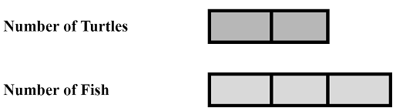
If there are currently 4 turtles in the pond, how many fish are there?

6

- The tape diagram represents the ratio of cheese to meat on a sandwich.
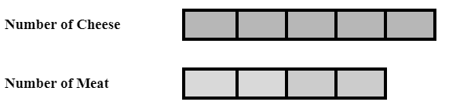
What is the ratio of cheese to meat?
5:4

